**Digital Nurture 4.0 Deep Skilling - Java FSE**  
**WEEK –3 Hands-on Exercises**  
**Module 5 - Spring Core and Maven**

**1. Exercise 1: Configuring a Basic Spring Application**

**Scenario:**

Your company is developing a web application for managing a library. You need to use the Spring Framework to handle the backend operations.

**Solution:**

**Spring Core:**

Spring Core is the foundational module of the Spring Framework, which provides the basic features of dependency injection (DI) and inversion of control (IoC) .

**Maven:**

Maven is a build automation and dependency management tool used in Java projects. It uses an XML file called pom.xml.

**Code:**

**Pom.xml**  
<?xml version="1.0" encoding="UTF-8"?>

<project xmlns="http://maven.apache.org/POM/4.0.0" xmlns:xsi="http://www.w3.org/2001/XMLSchema-instance"

xsi:schemaLocation="http://maven.apache.org/POM/4.0.0 http://maven.apache.org/xsd/maven-4.0.0.xsd">

<modelVersion>4.0.0</modelVersion>

<groupId>com.library</groupId>

<artifactId>LibraryManagement</artifactId>

<version>0.0.1-SNAPSHOT</version>

<packaging>jar</packaging>

<name>LibraryManagement</name>

<url>http://www.example.com</url>

<properties>

<project.build.sourceEncoding>UTF-8</project.build.sourceEncoding>

<maven.compiler.source>1.8</maven.compiler.source>

<maven.compiler.target>1.8</maven.compiler.target>

</properties>

<dependencies>

<dependency>

<groupId>org.junit.jupiter</groupId>

<artifactId>junit-jupiter-engine</artifactId>

<version>5.7.1</version>

<scope>test</scope>

</dependency>

<dependency>

<groupId>org.junit.jupiter</groupId>

<artifactId>junit-jupiter-params</artifactId>

<version>5.7.1</version>

<scope>test</scope>

</dependency>

<dependency>

<groupId>org.springframework</groupId>

<artifactId>spring-context</artifactId>

<version>5.3.33</version>

</dependency>

</dependencies>

<build>

<plugins>

<plugin>

<groupId>org.apache.maven.plugins</groupId>

<artifactId>maven-surefire-plugin</artifactId>

<version>3.0.0-M5</version>

</plugin>

</plugins>

</build>

</project>

**BookRepository.java**

package com.library.repository;

public class BookRepository {

public void saveBook(String bookName) {

System.out.println("Book saved: " + bookName);

}

}

**BookService.java**

package com.library.service;

import com.library.repository.BookRepository;

public class BookService {

private BookRepository bookRepository;

public void setBookRepository(BookRepository bookRepository) {

this.bookRepository = bookRepository;

}

public void addBook(String bookName) {

System.out.println("Adding book: " + bookName);

bookRepository.saveBook(bookName);

}

}

**applicationContext.xml**

<?xml version="1.0" encoding="UTF-8"?>

<beans xmlns="http://www.springframework.org/schema/beans"

xmlns:xsi="http://www.w3.org/2001/XMLSchema-instance"

xsi:schemaLocation="

http://www.springframework.org/schema/beans

https://www.springframework.org/schema/beans/spring-beans.xsd">

<bean id="bookRepository" class="com.library.repository.BookRepository" />

<bean id="bookService" class="com.library.service.BookService">

<property name="bookRepository" ref="bookRepository" />

</bean>

</beans>

**LibraryApp.java**

package com.library.LibraryManagement;

import com.library.service.BookService;

import org.springframework.context.ApplicationContext;

import org.springframework.context.support.ClassPathXmlApplicationContext;

public class LibraryApp {

public static void main(String[] args) {

ApplicationContext context = new

ClassPathXmlApplicationContext("applicationContext.xml");

BookService bookService = (BookService) context.getBean("bookService");

bookService.addBook("The Great Gatsby");

}

}

**Output:**

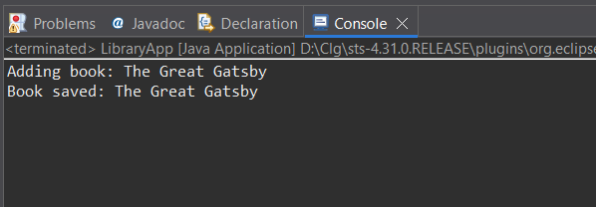

**Explanation:**

1. Create a Maven project named LibraryManagement in your IDE.
2. Add Spring Core dependencies in the pom.xml file.
3. Create an XML file named applicationContext.xml inside src/main/resources.
4. Define beans for BookService and BookRepository in the XML configuration.
5. Create the BookService class inside the com.library.service package.
6. Create the BookRepository class inside the com.library.repository package.
7. Create a main class to load the Spring application context and test the configured beans.

**2. Exercise 2: Implementing Dependency Injection**

**Scenario:**

In the library management application, you need to manage the dependencies between the BookService and BookRepository classes using Spring's IoC and DI.

**Solution:**

**Code:**

**applicationContext.xml**

<?xml version="1.0" encoding="UTF-8"?>

<beans xmlns="http://www.springframework.org/schema/beans"

xmlns:xsi="http://www.w3.org/2001/XMLSchema-instance"

xsi:schemaLocation="

http://www.springframework.org/schema/beans

https://www.springframework.org/schema/beans/spring-beans.xsd">

<bean id="bookRepository" class="com.library.repository.BookRepository" />

<bean id="bookService" class="com.library.service.BookService">

<property name="bookRepository" ref="bookRepository" />

</bean>

</beans>

**BookService.java**

package com.library.service;

import com.library.repository.BookRepository;

public class BookService {

private BookRepository bookRepository;

public void setBookRepository(BookRepository bookRepository) {

this.bookRepository = bookRepository;

}

public void addBook(String bookName) {

System.out.println("Adding book: " + bookName);

bookRepository.saveBook(bookName);

}

}

**LibraryApp.java**

package com.library;

import com.library.service.BookService;

import org.springframework.context.ApplicationContext;

import org.springframework.context.support.ClassPathXmlApplicationContext;

public class LibraryApp{

public static void main(String[] args) {

ApplicationContext context = new

ClassPathXmlApplicationContext("applicationContext.xml");

BookService bookService = (BookService) context.getBean("bookService");

bookService.addBook("Spring in Action");

}

}

**Output:**

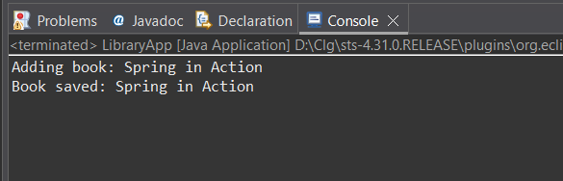

**Explanation:**

1. Update the applicationContext.xml to define a bean for BookService and inject BookRepository into it using a setter.
2. Add a setter method in the BookService class to receive the BookRepository dependency.
3. Run the LibraryApp main class to load the Spring context and confirm that dependency injection is working correctly.

**3. Exercise 4: Creating and Configuring a Maven Project**

**Scenario:**

You need to set up a new Maven project for the library management application and add Spring dependencies.

**Solution:**

**Code:**

**pom.xml**

<project xmlns="http://maven.apache.org/POM/4.0.0"

xmlns:xsi="http://www.w3.org/2001/XMLSchema-instance"

xsi:schemaLocation="http://maven.apache.org/POM/4.0.0

http://maven.apache.org/xsd/maven-4.0.0.xsd">

<modelVersion>4.0.0</modelVersion>

<groupId>com.library</groupId>

<artifactId>LibraryManagement</artifactId>

<version>1.0-SNAPSHOT</version>

<properties>

<maven.compiler.source>1.8</maven.compiler.source>

<maven.compiler.target>1.8</maven.compiler.target>

</properties>

<dependencies>

<dependency>

<groupId>org.springframework</groupId>

<artifactId>spring-context</artifactId>

<version>5.3.33</version>

</dependency>

<dependency>

<groupId>org.junit.jupiter</groupId>

<artifactId>junit-jupiter-api</artifactId>

<version>5.9.3</version>

<scope>test</scope>

</dependency>

<dependency>

<groupId>org.junit.jupiter</groupId>

<artifactId>junit-jupiter-engine</artifactId>

<version>5.9.3</version>

<scope>test</scope>

</dependency>

</dependencies>

<repositories>

<repository>

<id>central</id>

<url>https://repo.maven.apache.org/maven2</url>

</repository>

</repositories>

<build>

<plugins>

<plugin>

<groupId>org.apache.maven.plugins</groupId>

<artifactId>maven-compiler-plugin</artifactId>

<version>3.8.1</version>

<configuration>

<source>1.8</source>

<target>1.8</target>

</configuration>

</plugin>

</plugins>

</build>

</project>

**Output:**

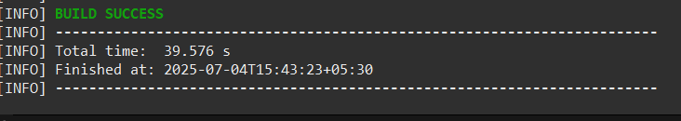

**Explanation:**

1. Create a new Maven project named LibraryManagement in your IDE.
2. Add dependencies for Spring Context, Spring AOP, and Spring WebMVC in the pom.xml file.
3. Configure the Maven Compiler Plugin in pom.xml to set the Java version to 1.8.